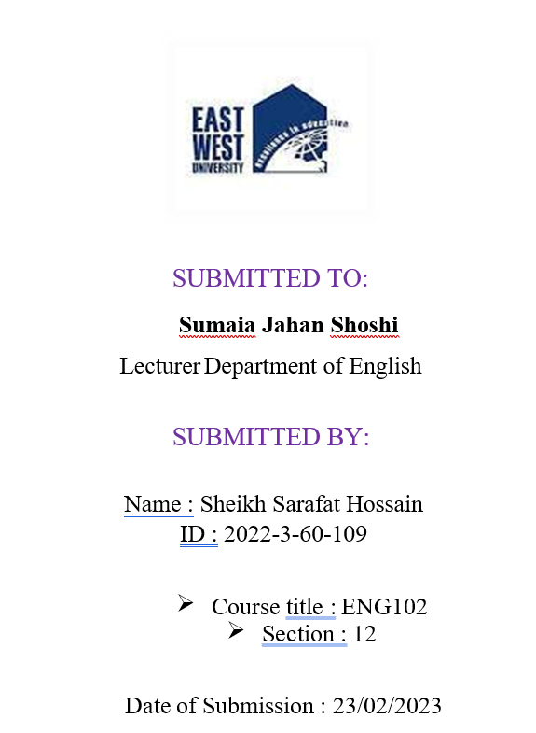
International Language Day as a fresher

Outline:
- Introduction
- History
- Significance
- Celebration
- My Experience
- Conclusion

Introduction: International Language Day is celebrated worldwide on 21st February every year to promote linguistic diversity and multilingualism. As a fresher at my university, I had the opportunity to observe this day, which was an enlightening experience. This day reminds us the history, sacrifice of 1952 which made us proud.
History: On February 21, 1952, students and activists in East Pakistan (Now Bangladesh) protested the Pakistani government's decision to impose Urdu as the only official language of the country. During the protest, police opened fire on the demonstrators, killing several of them. This is one and only sacrifice of lives for the sake of the Mother Language in the history of mankind.
Significance: This day provides an opportunity to recognize the importance of preserving linguistic diversity and the role of language in promoting global citizenship, cultural exchange, and mutual understanding. It is a reminder that every language has its unique value, and each language deserves to be respected and celebrated.
Celebration: The preparations for the day started a week earlier. Various student from the cultural club took the initiative to arrange programs to celebrate the day. There were poetry recitation competitions, and cultural exhibitions. The university administration also organized seminars and lectures on the importance of language learning. On the day itself, the university was bustling with excitement. everyone mourns by wearing black clothes. The main event was held in our new auditorium, where students from different departments, cultures, and languages gathered to celebrate the day. The event started with the national anthem.
My Experience: As a student, I felt proud and honored to be a part of such a multicultural community. It was an eye-opening experience to witness the beauty and richness of different languages and cultures. The event helped me understand the importance of preserving and promoting linguistic diversity in our society.
Conclusion: To wrap things up, International Language Day is a significant event that promotes linguistic diversity and multilingualism. As a fresher at my university, I had the opportunity to observe this day and witness the beauty of different languages and cultures. It was an enriching experience that has left a lasting impression on me.

